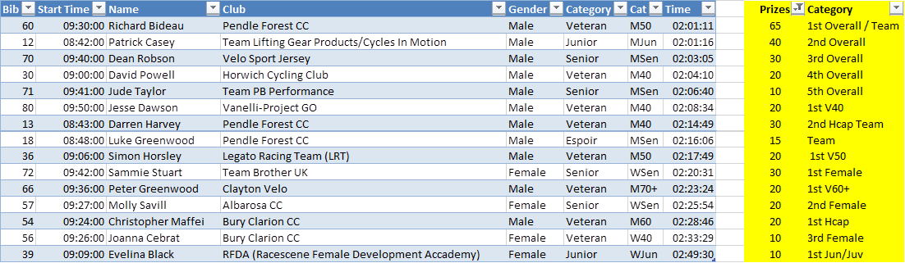

I WOULD LIKE TO THANK ALL THE RIDERS TODAY FOR TAKING PART IN THIS ICONIC EVENT.

PLEASE NOTE THAT IF YOUR NAME IS ON THIS LIST WE WILL NEED YOUR BANK DETAILS TO TRANSFER YOUR WINNINGS.

PLEASE E MAIL THEM TO ME .